1. **Why to deny all the requests**:
   1. Business may have some peculiar business requirements that my server should not accept any requests, even though they have proper credentials during some midnight time or some particular timeframe.
   2. In such scenario, Spring Security provides a feature of denying all the requests.
2. 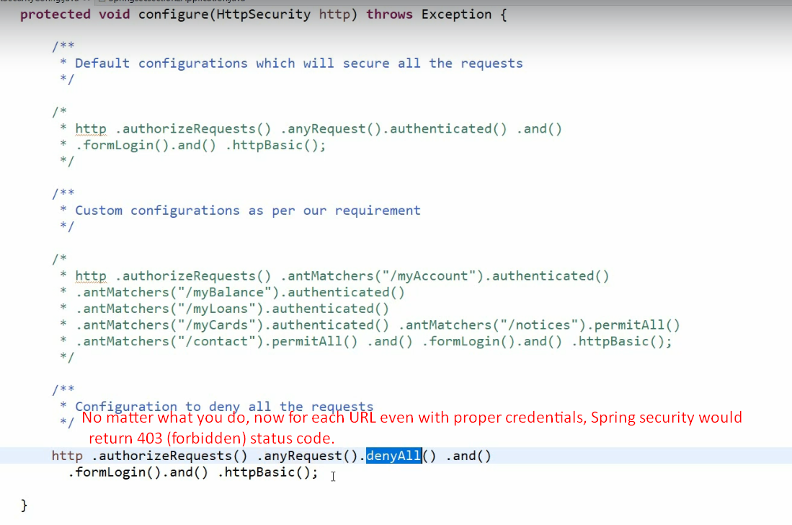
3. 